H.T.NO:2303A51038
BATCH 28
TASK 1:
Prompt:
Use AI to generate a Python script for cleaning a customer dataset that handle missing values in columns (age, income, city),Remove duplicate records, Standardize text values (e.g., city names in lowercase) and Encode categorical variables (gender, city).
Data Cleaning Steps
I will perform the following steps to clean the shopping_trends.csv dataset:
- Handle Missing Values: Impute missing values in 'age' and 'income' with their respective means, and in 'city' with its mode.
- Remove Duplicate Records: Eliminate any duplicate rows in the dataset.
- Standardize Text Values: Convert 'city' names to lowercase for consistency.
- Encode Categorical Variables: Encode 'gender' to numerical values (e.g., 0/1) and 'city' using one-hot encoding.

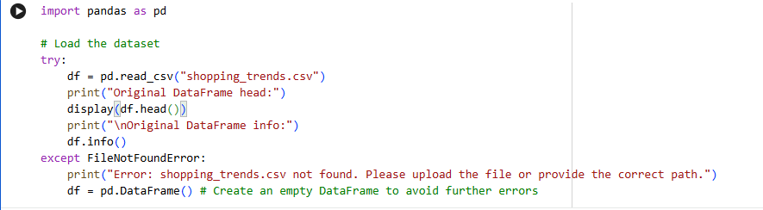
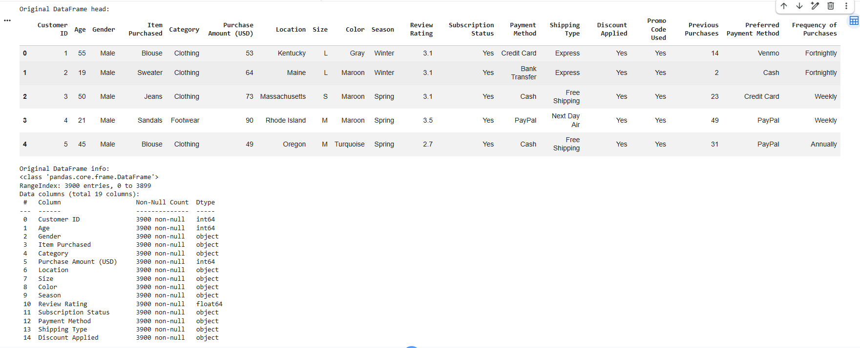
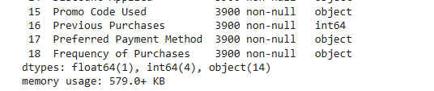
1. Handle Missing Values
- Numerical columns (age, income): Impute with the mean.
- Categorical column (city): Impute with the mode.
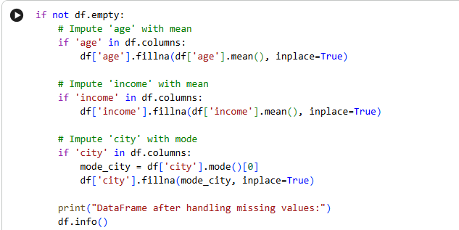
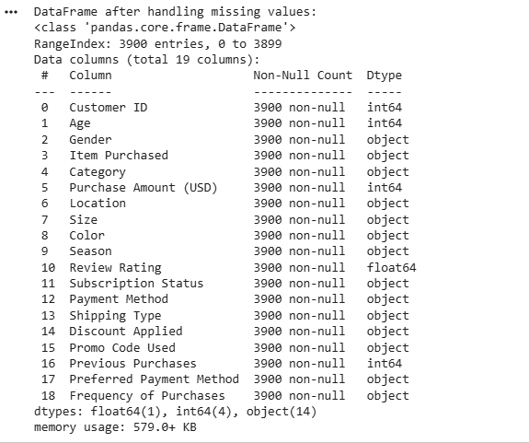
2. Remove Duplicate Records
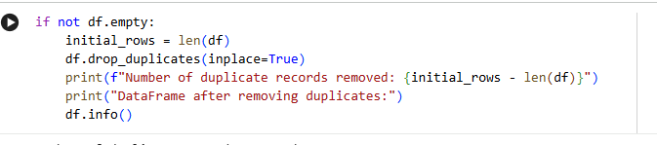
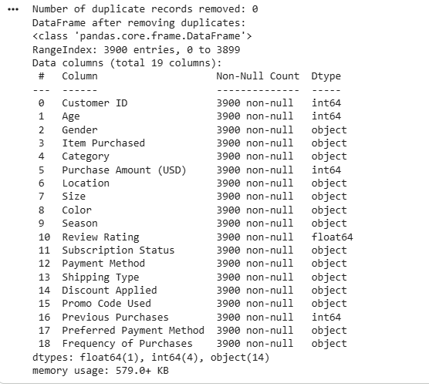
3. Standardize Text Values (City Names to Lowercase)
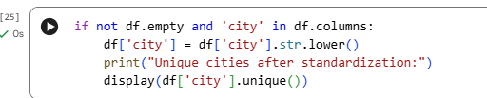
4. Encode Categorical Variables
- Gender: Using a simple mapping (e.g., 'Male' -> 0, 'Female' -> 1).
- City: Using one-hot encoding.
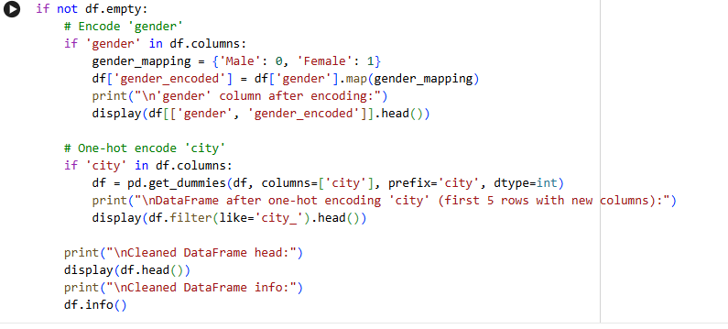
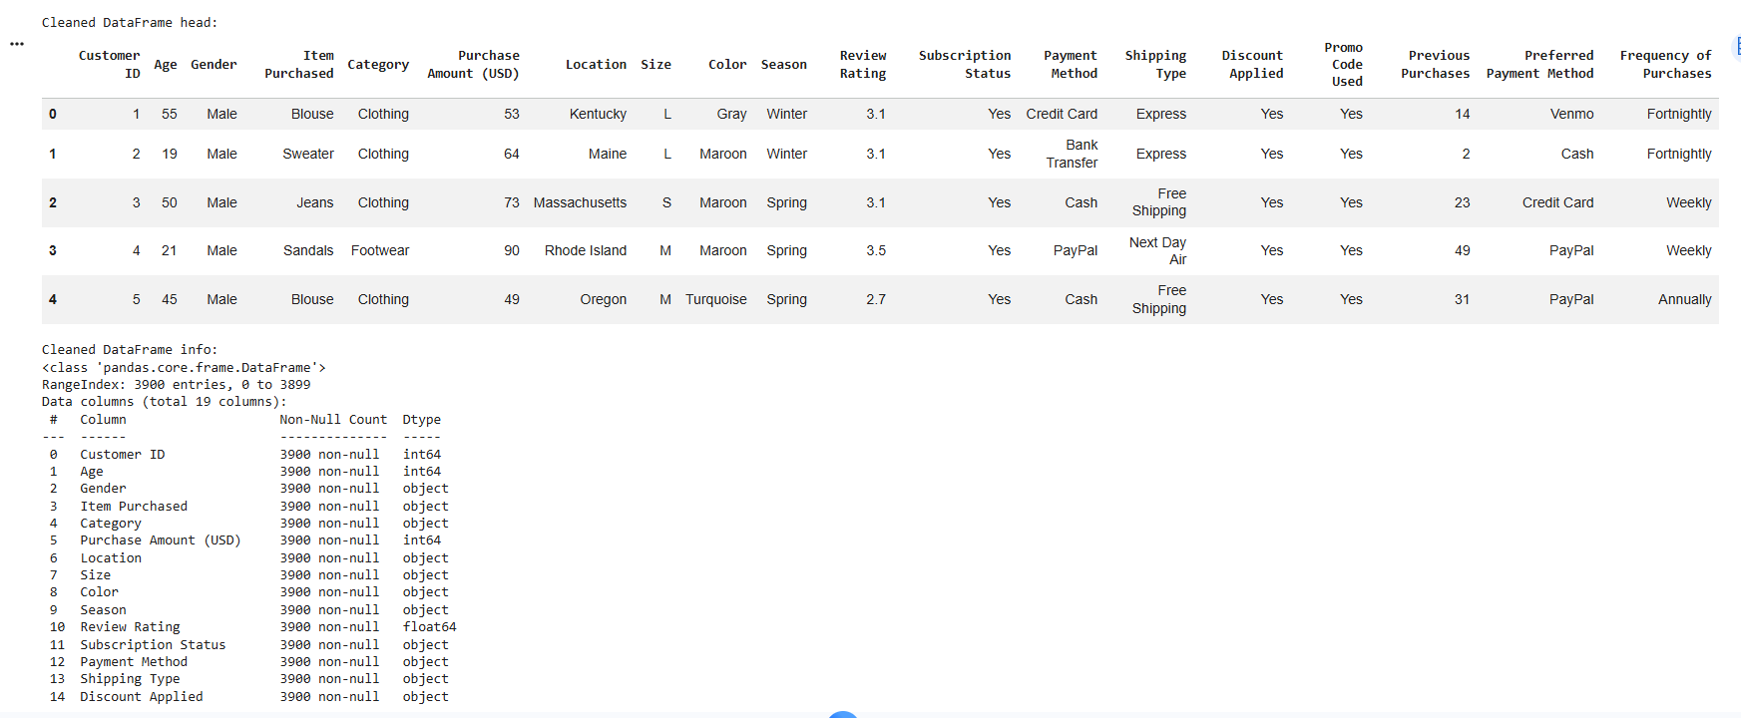
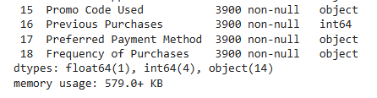
TASK 2:
Prompt:
Preprocess sales transaction data using AI assistance that converts date columns into datetime format, Create new features (month, year, day of week),Normalize sales amount column, and Detect and handle outliers in dataset.
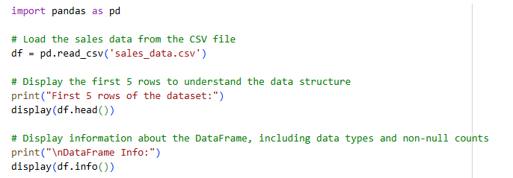
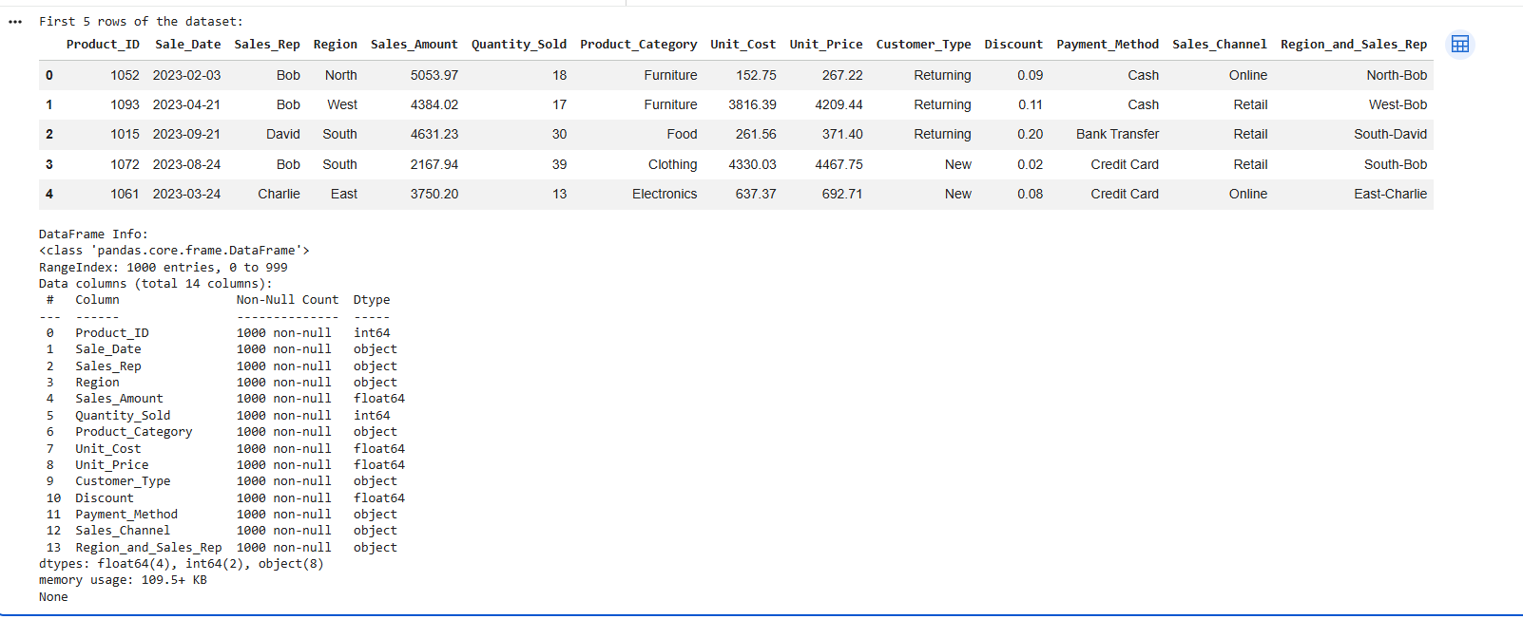
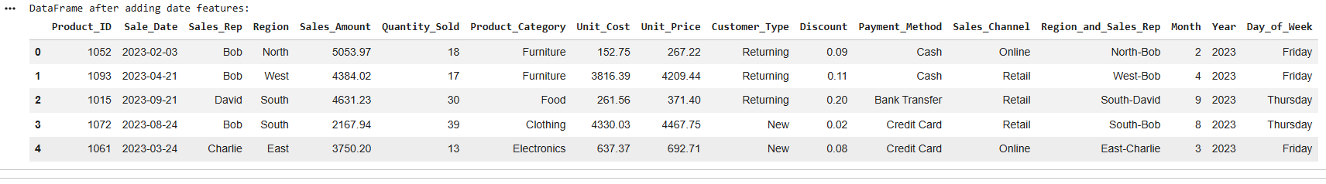
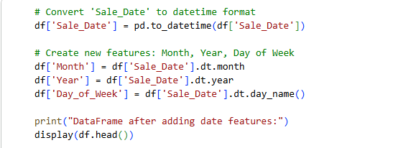

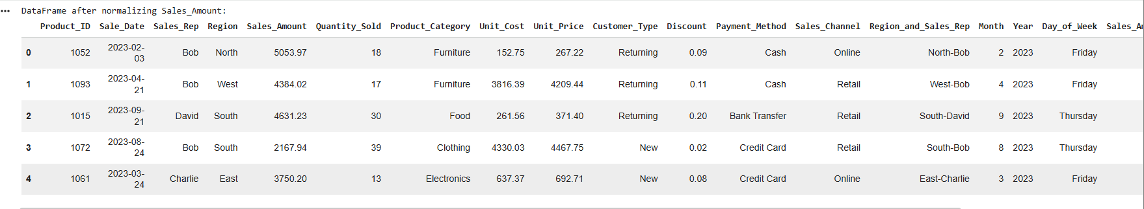
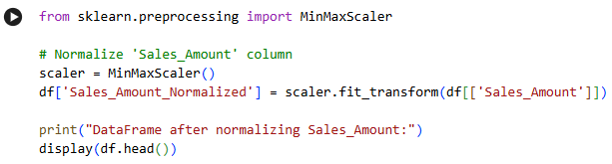
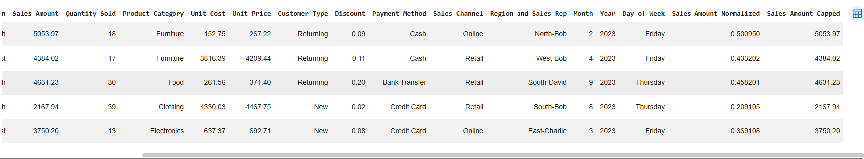

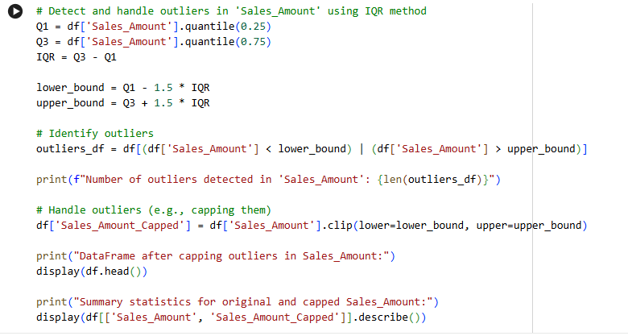
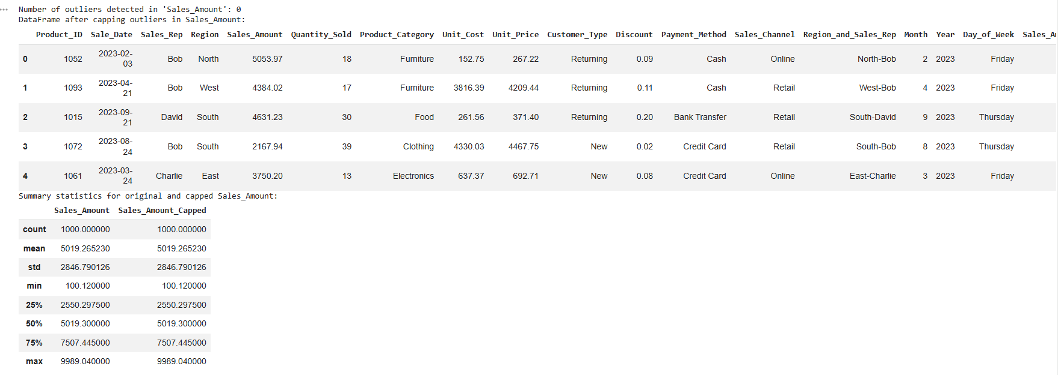
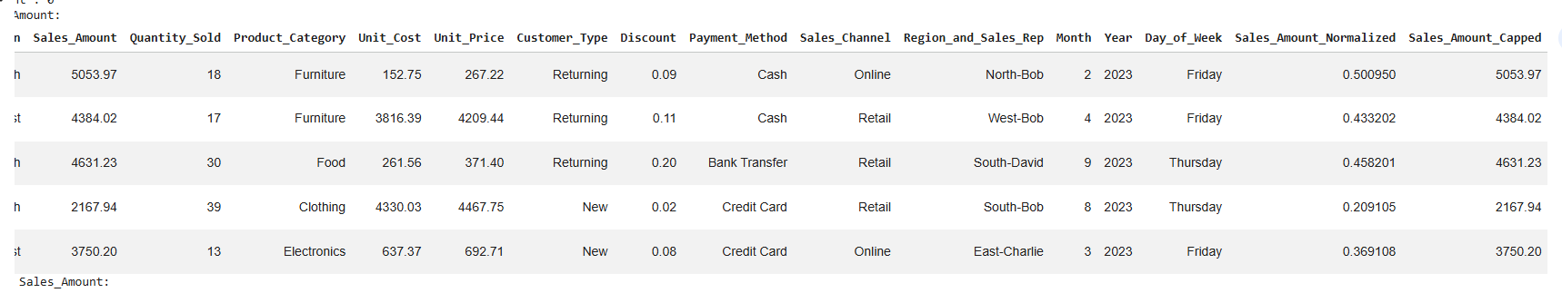
TASK 3:
Prompt:
Clean and preprocess a healthcare dataset using AI Scripts that handle missing values in blood_presure, cholesterol, Encode Categorical Features, Scale numerical features(min-max or standard scaling), and split the dataset into training and testing datasets.
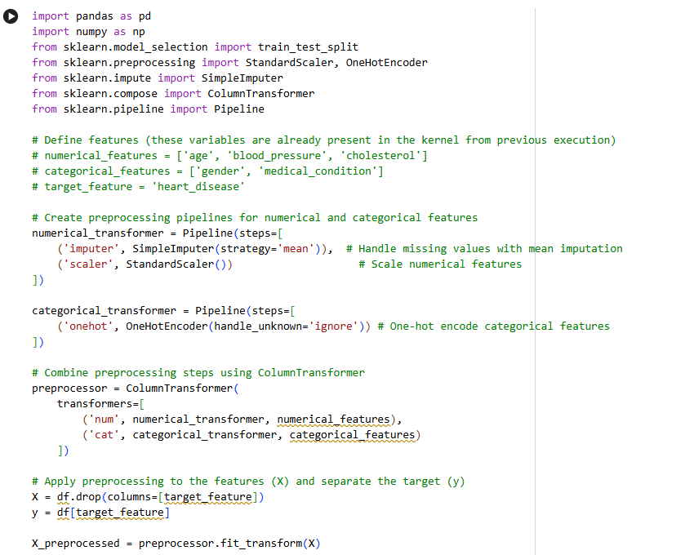
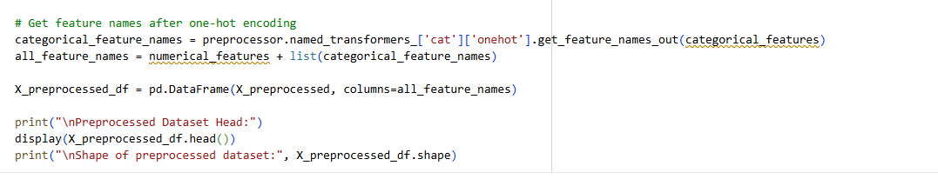
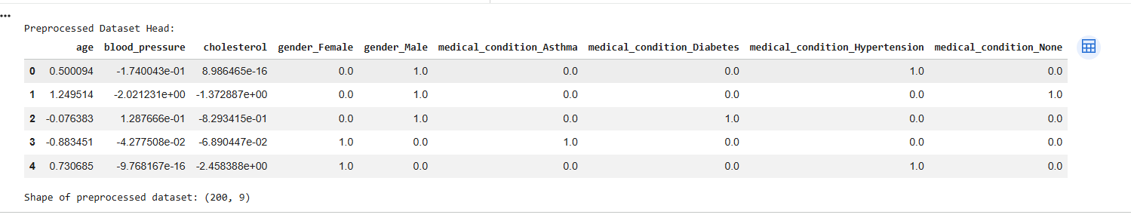
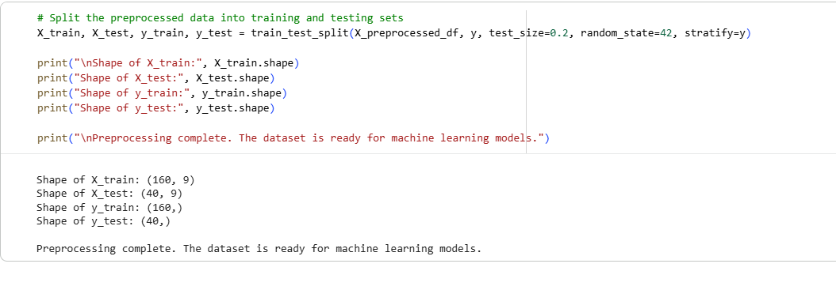
TASK 4:
Prompt:
Clean and preprocess an employee salary dataset using AI Scripts that handle missing values, Detect and remove salary outliers, Standardize department names(lowercase), Apply label encoding to job location, department.
Data Cleaning and Preprocessing
First, let's create a sample employee salary dataset for demonstration purposes.
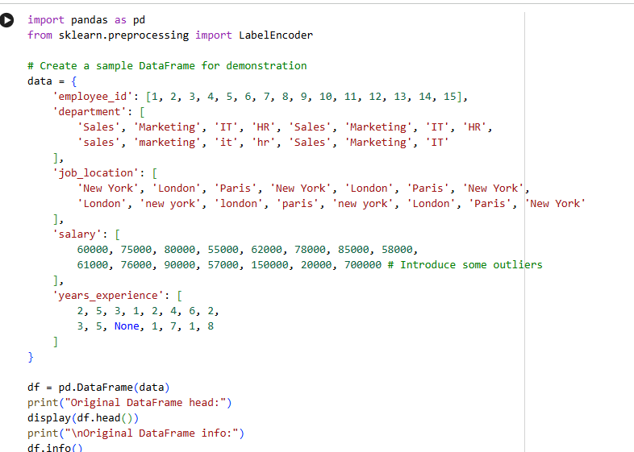
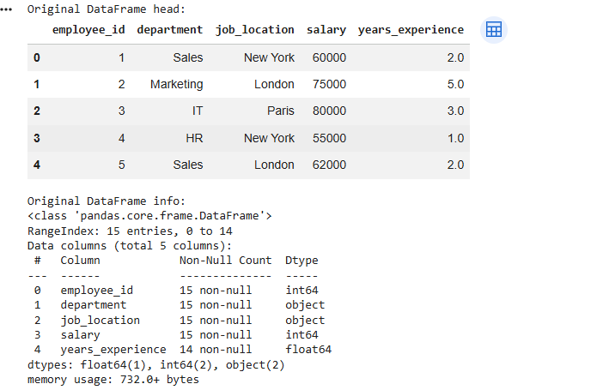
1. Handle Missing Values
We'll check for missing values and fill years_experience with the median, and drop rows with any other missing values. You can adjust the strategy (e.g., fill with mean, mode, or use imputation techniques) based on your dataset's characteristics.

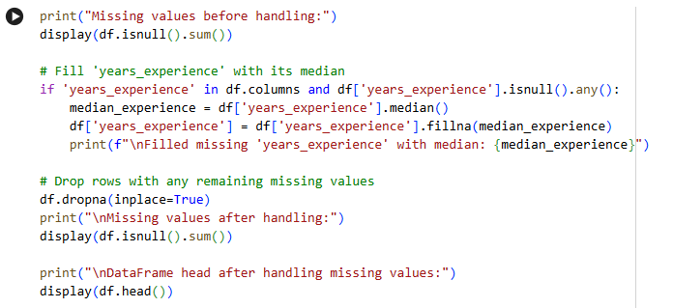
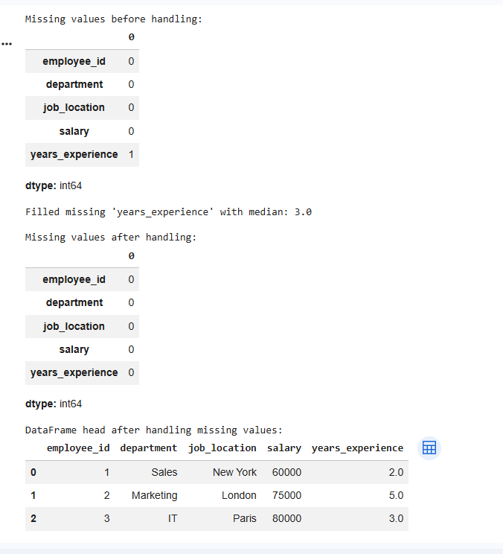

2. Detect and Remove Salary Outliers
We'll use the Interquartile Range (IQR) method to detect and remove outliers from the 'salary' column. This method defines outliers as values that fall below Q1 - 1.5 * IQR or above Q3 + 1.5 * IQR.
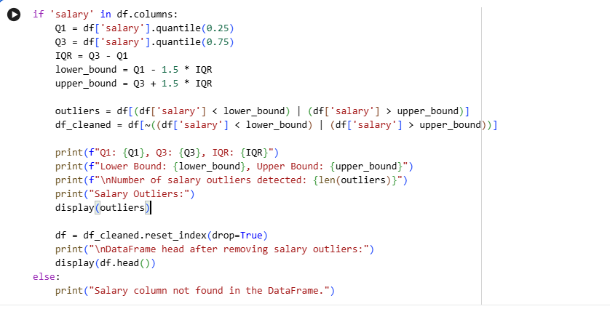
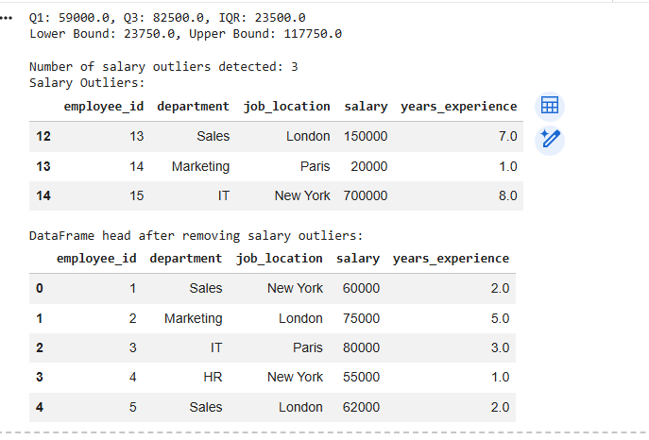
3. Standardize Department Names (lowercase)
This step ensures consistency across department names by converting all entries to lowercase.
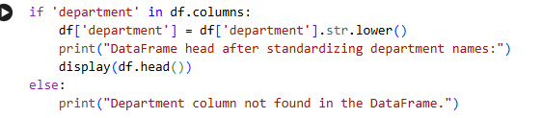
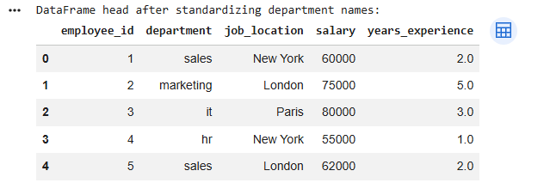
4. Apply Label Encoding to Job Location and Department
Label Encoding converts categorical text data into numerical labels, which is necessary for many machine learning models. Each unique category will be assigned a unique integer.
